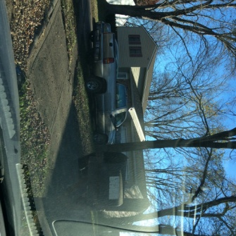
Exit Inspection
Suite 6, 18 Broadway
Inspected By: Zoe Clark
15/03/2016

With our Smart Report function, we can completely customize the checklist, the look of the report, and apply additional business rule with the data collected according to your requirement. To learn more, please contact support@snapinspect.com and we will quickly send you few sample reports.

Gas Meter Reading | 364.443 | Photograph? Y
Electrical Meter Reading | 443 10 | Photograph? Y
Water Meter Reading | No meter found | Photograph? N

Blinds Kitchen - PRESENCE OF SECURING DEVICE FOR OVERLONG / LOOPING CORDS | N
Blinds Bathroom - PRESENCE OF SECURING DEVICE FOR OVERLONG / LOOPING CORDS | NA
Blinds Safety Regulations Leaflet provided for Tenant | NA

 | Room Name | Present? | Working Order? | Comments
Smoke Alarm Present? | Entrance | Y | Y
 | Lounge | N | N
 | Toilet | N | N
 | Garage/Carport | NA | NA
 | Laundry | NA | NA
 | Bedroom 3 | N | N
 | Bedroom 2 | N | N
 | Bedroom | N | N
 | Bathroom | N | N
 | Kitchen | N | N

Video Inspection Link: Click To View

Name | Clean | Undamaged | Working | Comments
Entrance
Doors & Locks | Y | Y | Y
Walls & Ceiling | Y | Y | Y
Floor/Coverings | Y | Y | Y
Windows & Locks
Lights & Power Points
Lounge
Doors & Locks | Y | Y
Walls & Ceiling | Y | Y | Y | Skirting boards coming away from wall. Tenant has left new chrome light fitting.
Floor/Coverings | Y | Y | Y
Windows & Locks | Y | Y | Y | Cracking above the rear lounge window
Lights & Power Points | Y | Y | Y
Blinds/Curtains | Y | Y | Y | Nets at both windows
- | - | -
- | - | -

Kitchen
Doors & Locks | Y | Y | Y
Walls & Ceilings | Y | Y | Y
Floor/Coverings | Y | Y | Y | Two small raised areas on kitchen floor
Windows & Locks | Y | Y | Y
Lights & Power Points | Y | Y | Y
Cupboards/Drawers/Bench Tops | Y | Y | Y | Additional photographs taken separately
Sink/Taps/Spout | Y | Y | Y
Stove/Hobs/Griller | Y | Y | Y | Slight tarnishing on rear hob cover
Appliances |  |  |  | Oven & extractor have been cleaned
- | - | -

Bedroom
Doors & Locks | Y | Y | Y
Walls & Ceilings | Y | Y | Y
Floor/Coverings | Y | Y | Y
Windows & Locks | Y | Y | Y | Small area in the corners of the window sill showing potential signs of damp/mould.
Blinds/Curtains | Y | Y | Y | White net blinds at both windows
Lights & Power Points | Y | Y | Y
Built-ins/Mirrors
- | - | -

Bedroom 2
Doors & Locks | Y | Y | Y
Walls & Ceilings | Y | Y | Y
Floor/Coverings | Y | Y | Y
Windows & Locks | Y | Y | Y
Blinds/Curtains | Y | Y | Y | White net blinds
Lights & Power Points | Y | Y | Y
Built-ins/Mirrors | Y | Y | Y
- | - | -
- | -

Bedroom 3
Doors & Locks | Y | Y | Y
Walls & Ceilings | Y | Y | Y
Floor/Coverings | Y | Y | Y
Windows & Locks | Y | Y | Y
Blinds/Curtains | Y | Y | Y | White net blinds
Lights & Power Points | Y | Y | Y
Built-ins/Mirrors
- | - | -

Toilet
Doors & Locks | Y | Y | Y
Walls & Ceilings | Y | Y | Y
Floor/Coverings | Y | Y | Y
Windows & Locks | Y | Y | Y
Lights & Power Points | Y | Y | Y
Toilet/Toilet Roll Holder

General Comment
Sample General Comments

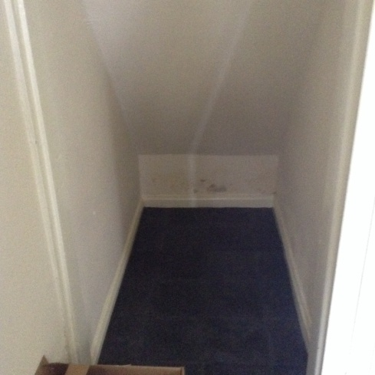  - | 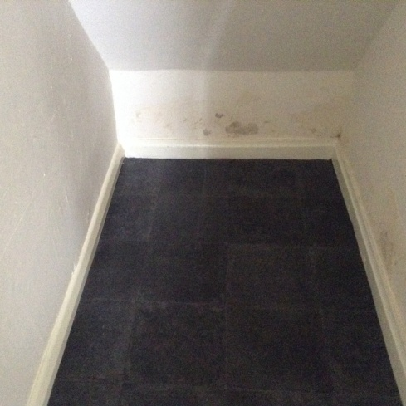  - | 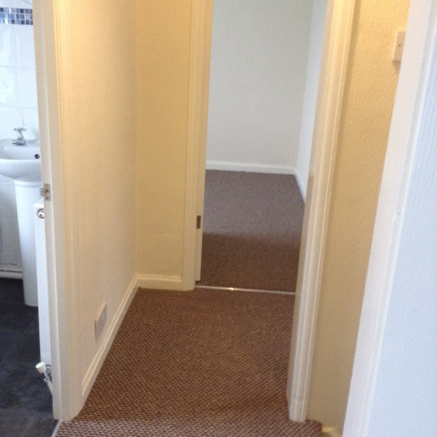  -
Maintenance Comments
Sample Maintenance Comments

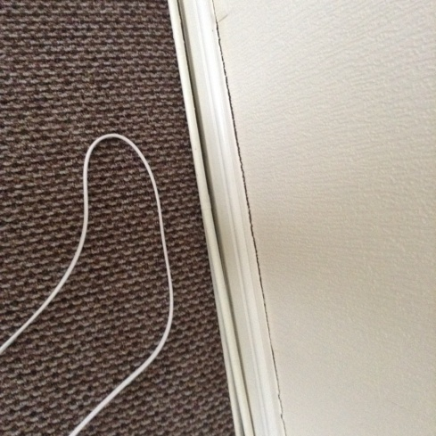  - | 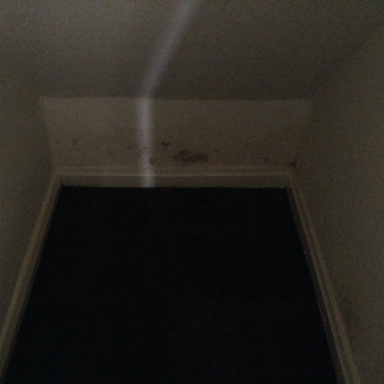  - | 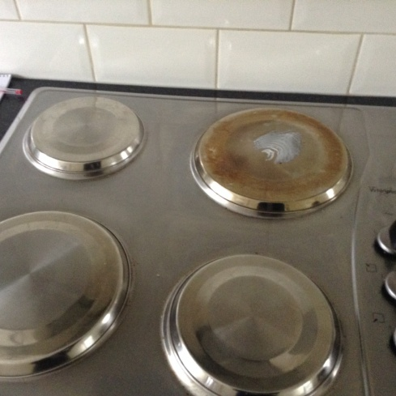  -

COPIES OF APPLIANCE MANUALS PROVIDED
Y

Tenant Signature | 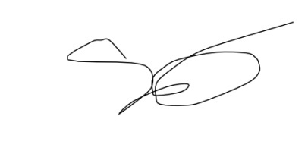 | Date: 15/03/2016
Inspector Signature |  | Date: 15/03/2016

DISCLAIMER
This report is undertaken by [Your Company Name] and provides a fair and accurate record of the condition and contents of the property, and the property's internal condition. It is the responsibility of the Landlord and the Tenant to agree between themselves the accuracy of this report.
The person preparing this report is not an expert in fabrics, woods, materials, colours, paint colours, antiques etc, nor a qualified surveyor. The report should not be used as structural survey report. Plants and shrubs are not listed. If any additional items are to be listed, this will be at the Landlords request.
Property left in lofts, cellars and locked rooms, which have not been inventoried, are the sole responsibility of the Landlord.

GENERAL REPORT GUIDELINES
Electrical items will not be checked apart from; light bulbs and extractor fans in kitchens and bathrooms. Please be advised that Inventory Clerks are not responsible for the following:-
1. Testing showers/taps
2. Testing appliances
3. Moving furniture
4. Checking electrical items
5. Flushing toilets
6. Checking heating systems/radiators
7. Inspecting loft contents
8. Removing and inspecting boxed items

