Entry condition report - general tenancies (Form 14a)
Residential Tenancies and Rooming Accommodation Act 2008
(Section 66)
Address of the rental premises  Address  Raceview QLD 4305 Postcode  Details of the tenant/s  1. Full name/s  Forwarding address  Postcode  Phone Mobile  Email  2. Full name/s  Forwarding address  Postcode  Phone Mobile  Email  3. Full name/s  Forwarding address  Postcode  Phone Mobile  Email  Name/trading name of the lessor/agent  Trade Name  Water meter reading at end of tenancy Date | The Entry (and Exit) reports provide evidence of the condition of the premises at the  beginning and ending of the tenancy. Take time to fill these forms in carefully. These  documents may be referred to as evidence if there is a dispute over the bond refund  at the end of the tenancy.  Lessor/agent  1. Inspect the premises.  2. Mark each item on the listclean, working, undamaged(where applicable).  3. Make a note of any extra items in theadditional comments/informationsection.  4.Initial each page of the report. Give it to thelessor/agent asssonas possible once theaggreementends.  5.Talk to thelessor/agent if you disagree about the condition of the premises. Comments can be recorded in the additional comments/information section (Page 7)or by attaching aseperatepage.  Supporting documentation has been attached YesNo  6. Retain the signed copy of the report from the lessor/agent.  Tenant  1. Inspect the premises.  2. Include comments where you disagree the tenant's report.  3.Initial each page of the report.  4.Talk to the tenant if you disagree about the condition of the premises. Any agreement can be recorded in theadditional comments/informationsection.  5Return a signed copy of the report to the tenant within 3 business days. Retain a copy for at least one year after the tenancy agreement ends.  Note: The Entry condition report (Form 1a) is compared to this Exit condition report (Form 14a) at the end of the tenancy.  Do not send to the RTA - give this form to thelessor/agent, kee a copy of your records.

Entry condition report - general tenancies (Form 14a)

Residential Tenancies and Rooming Accommodation Act 2008
(Section 65)
Insert Y = Yes  Insert N = No | Clean | Working | Undamaged | Lessor/agent  Comments (if any) |  | Tenant/s  Comment onlessor/agent report
Entry 1
Doors/walls | Y | Y | Y | 1 security screen very good condition, 1 green and cream wooden door with door stop,
Windows/screens | Y | Y | Y | Clean and tidy
Blinds/curtains |  |  |  | N/A
Ceiling/light fittings | Y | Y | Y | 1 outside light
Floor/floor coverings | Y | Y | Y | Tiles
Power points |  |  |  | N/A
doorbell | Y | Y | Y | Working
Lounge Room 1
Doors/walls | Y | Y | Y | Clean and tidy Scuff marks present minor marks/stains
Windows/screens | Y | Y | Y | Clean and tidy
Blinds/curtains | Y | Y | Y | 1 long set and 1 medium set vertical blinds with chain
Ceiling/light fittings | Y | Y | Y | Hallway - 1 downlight, 1 smoke alarm, lounge- 2 down lights, 1 oyster light shade light fitting , 1 ceiling fan that wobbles and makes lots of noise when turned on; 1 Hisense brand air conditioner, working.
Floor/floor coverings | Y | Y | Y | Tiled, some discolouration in grout
TV/power points | Y | Y | Y | 3 db pp; 1 TV, 1 foxtel
linen press | Y | Y | Y | 1 shelf
Dining Room 1
Doors/walls | Y | Y | Y | minor marks/stains, 1 crack near back window
Windows/screens | Y | Y | Y | 2 windows, 1 sliding door all with screens in good condition and all tracks clean
Blinds/curtains | Y | Y | Y | 3 sets of verticals with chains vgc
Ceiling/light fittings | Y | Y | Y | 2 down lights , 1 smoke alarm, 1 door bell chime speaker, 1 water mark on ceiling between kitchen and dining, 1 ceiling fan that wobbles and squeaks badly when on
Floor/floor coverings | Y | Y | Y | Tiled, some discolouration in grout
TV/power points | Y | Y | Y | 1 db pp, 1 TV, 1 foxtel
cupboard | Y | Y | Y | Brown with silver handles
linen press | Y | Y | Y
Kitchen/Meals 1
Doors/walls | Y | Y | Y | Clean and tidy Scuff marks present
Windows/screens | Y | Y | Y | 1 long window , tracks and screen clean and good condition, 1 set long verticals with chain
Blinds/curtains | Y | Y | Y | Verticals with chain
Ceiling/light fittings | Y | Y | Y | 2 down lights in meals area, 1 round fluro with no cover in kitchen, cover broken ... Light switch has middle switch that reads fan... It's not for fan but for light in meals area, large gap in ceiling between joins from lounge to meals area
Floor/floor coverings | Y | Y | Y | Tiled, grout discoloured
Cupboards/drawers | Y | Y | Y | Brown with silver handles, and beige with silver handles minor marks/stains
Bench tops/tiling | Y | Y | Y | Speckled, minor wear and tear marks
Sink/disposal unit/taps | Y | Y | Y | 1.5 SS sink with ss flick mixer , 2 ss drainers
Stove top/griller | Y | Y | Y | Ceramic 4 burner hot plate with minor wear and tear marks
Oven | Y | Y | Y | oven with griller tray and 3 silver racks
Exhaust fan/rangehood | Y | Y | Y | Lights and exhaust work
Dishwasher | Y | Y | Y | With cutlery basket
Power points | Y | Y | Y | 3 double pp, 2 single pp, 1 ph
Family Room 1
Doors/walls
Windows/screens
Blinds/curtains
Ceiling/light fittings
Floor/floor coverings
Power points
Bedroom 1
Doors/walls | Y | Y | Y | Clean and tidy
Windows/screens | Y | Y | Y | 2 windows, screens in good condition, tracks clean
Wardrobe/drawers/shelves | Y | Y | Y | Clean and tidy Scuff marks present minor marks/stains
Blinds/curtains | Y | Y | Y | Verticals no chains
Ceiling/light fittings | Y | Y | Y | 1 oyster light fitting in wardrobe, 2 down lights in room , 1 ceiling fan
Floor/floor coverings | Y | Y | Y | Beige carpet, minor furniture indents
Power points | Y | Y | Y | 2 db pp, 1 single pp, 1 ph, 1 TV
Bedroom 2
Doors/walls | Y | Y | Y | Clean and tidy Scuff marks present minor marks/stains
Windows/screens | Y | Y | Y | Screen in good condition, track clean
Wardrobe/drawers/shelves | Y | Y | Y | 2 mirrored sliding door, Scuff marks present minor marks/stains
Blinds/curtains | Y | Y | Y | Verticals with chain
Ceiling/light fittings | Y | Y | Y | 2 down lights, 1 ceiling fan, noisy when on
Floor/floor coverings | Y | Y | Y | Beige carpet, minor furniture indents, 2 minor marks, 1 pull
Power points | Y | Y | Y | 1 db pp
Bedroom 3
Doors/walls | Y | Y | Y | Clean and tidy Scuff marks present minor marks/stains
Windows/screens | Y | Y | Y | Screen in vgc, tracks clean
Wardrobe/drawers/shelves | Y | Y | Y | Double mirrored door, some scuff marks on back wall
Blinds/curtains | Y | Y | Y | Verticals no chain
Ceiling/light fittings | Y | Y | Y | 2 down lights, 1 ceiling fan, bent on one blade
Floor/floor coverings | Y | Y | Y | Beige , some minor furniture indents
Power points | Y | Y | Y | 1 db pp
Ensuite 1
Doors/walls/tiling | Y | Y | Y | Clean and tidy
Windows/screens | Y | Y | Y | Frosted, screen and tracks clean and in gc
Blinds/curtains |  |  |  | N/A
Ceiling/light fittings | Y | Y | Y | 1 oyster light shade
Floor/floor coverings | Y | Y | Y | Tiles, some discolouration in tiles
Bath |  |  |  | N/ A
Shower/shower screen | Y | Y | Y | Clean and tidy, ss fittings
Wash basin/vanity | Y | Y | Y | Double basin, two flick mixers, 2 black plugs
Mirror/cabinet | Y | Y | Y | 1 rectangle mirror, 4 door cabinet
Towel rails | Y | Y | Y | 1 ss db rail
Toilet | Y | Y | Y | White dual flush; 1 ss roll holder
Power points | Y | Y | Y | 1 single pp
exhaust fan | Y | Y | Y
Bathroom 1
Doors/walls/tiling | Y | Y | Y | Clean and tidy
Windows/screens | Y | Y | Y | Frosted, tracks clean, screen in good condition
Blinds/curtains | Y | Y | Y | Verticals with chain
Ceiling/light fittings | Y | Y | Y | 1 oyster light fitting, 1 exhaust fan
Floor/floor coverings | Y | Y | Y | Tiled , some grout discoloured
Bath | Y | Y | Y | White, minor marks/stains, 1 white plug
Shower/shower screen | Y | Y | Y | Vgc, ss fittings
Wash basin/vanity | Y | Y | Y | Flick mixer, white basin, black plug, 2 door cabinet,
Mirror/cabinet | Y | Y | Y | Good condition
Towel rails | Y | Y | Y | 1 db ss rail
Toilet | Y | Y | Y | Separate, white dual flush, frosted window , tracks clean, screen vgc, 1 ss roll holder, tiled floor, 1 downlight
Power points | Y | Y | Y | 1 s pp
Laundry 1
Doors/walls | Y | Y | Y | Beige, good condition
Windows/screens | Y | Y | Y | 1x2 glass panel sliding door; 1 screen sliding door good condition, tracks clean
Blinds/curtains | Y | Y | Y | 1 set long verticals with chain
Ceiling/light fittings | Y | Y | Y | 1 oyster light fitting
Floor/floor coverings | Y | Y | Y | Tiled
Wash tubs | Y | Y | Y | 1 ss basin with flick mixer and 1 black plug, speckled bench top with 4 door cupboard underneath
Washing machine/dryer |  |  |  | N/ A
Power points | Y | Y | Y | 1 db pp, 1 hot and 1 cold washing machine tap fittings
General
Smoke alarms | Y | Y | Y
Security devices | Y | Y | Y
Electrical safety switches | Y | Y | Y
Balcony/porch/deck | Y | Y | Y
Garage/car port/storeroom | Y | Y | Y | Floor marked, 1 window with screen and verticals with chain gc, 1 manhole, 1 fluro no shade. DLUG
Gates/fences | Y | Y | Y
Grounds/garden | Y | Y | Y
Staircases/railings |  |  |  | N/A
Street number/letter box | Y | Y | Y
Paving/pergola | Y | Y | Y
Hot water system | Y | Y | Y
Keys/locks/remotes | Y | Y | Y
Pool/equipment |  |  |  | N/A
Wheelie & recycle bins | Y | Y | Y
Garden shed |  |  |  | N/ A
Air conditioner/fans | Y | Y | Y | Hisense in lounge room, most of the fans wobble and squeak badly when turned on
Bedroom 4
Doors/walls | Y | Y | Y | Clean and tidy, minor wear and tear marks... Study near entry
Windows/screens | Y | Y | Y | Tracks , windows and screens in good condition
Wardrobe/drawers/shelves |  |  |  | N/a
Blinds/curtains | Y | Y | Y | 1 set long verticals no chain and 1 set short verticals with chain
Ceiling/light fittings | Y | Y | Y | 2 down lights, 1 ceiling fan, 1 huge water mark on ceiling
Floor/floor coverings | Y | Y | Y | Beige carpet , some furniture indents , 1 small pull
Power points | Y | Y | Y | 1 ph, 1 double pp
Security
Lounge room
Electrical safety

Additional comments/Information |  | Lessor/agent  Signature Date:  Print name
Tenant1  Signature Date:  Print name | Tenant 2  Signature Date:  Print name | Tenant 3  Signature Date:  Print name

Photos From The Inspection
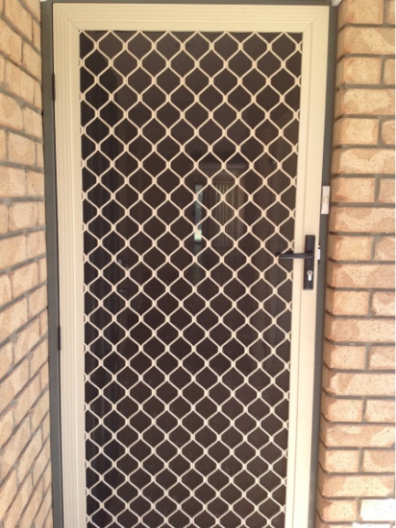  Entry 1 | 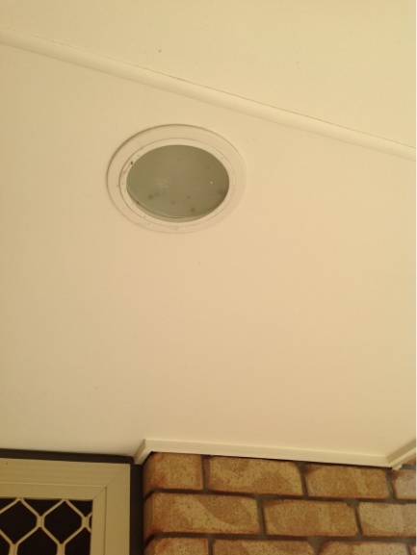  Entry 1 | 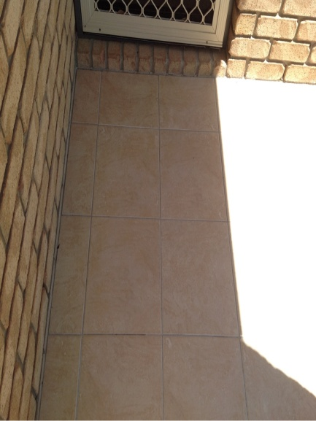  Entry 1
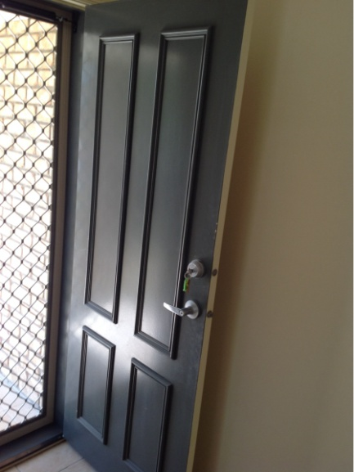  Entry 1 | 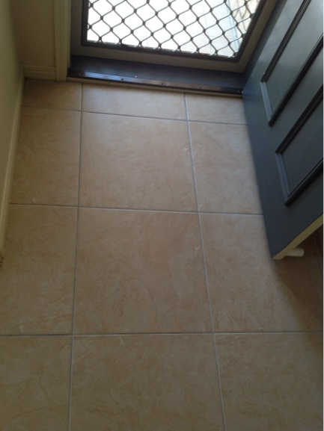  Entry 1 | 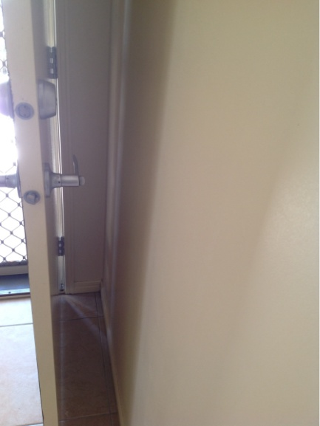  Entry 1
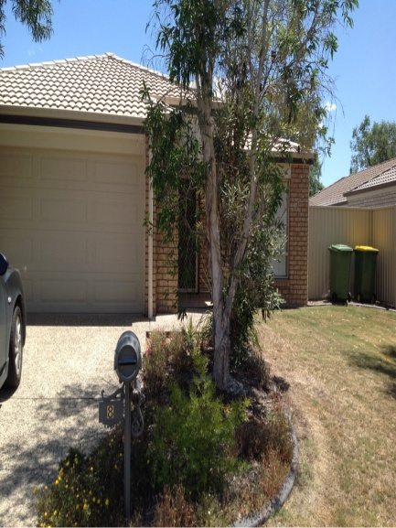  Entry 1 | 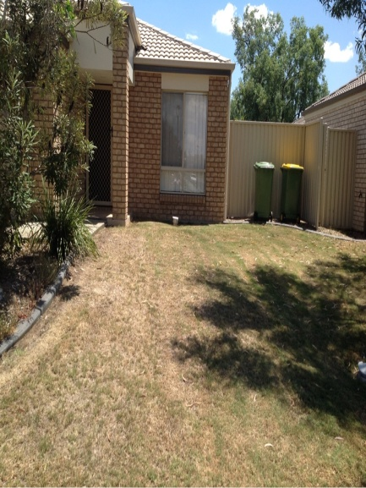  Entry 1 | 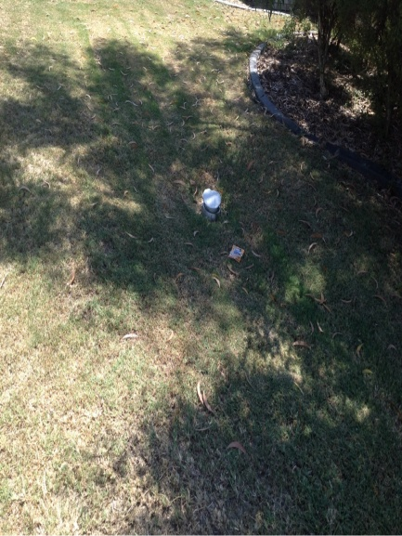  Entry 1
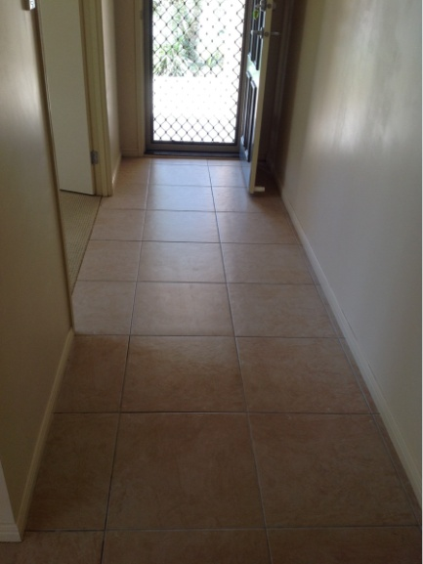  Lounge Room 1 | 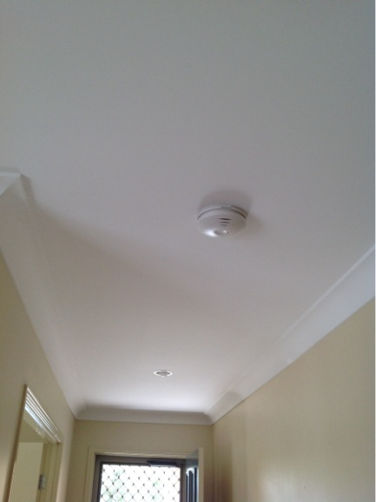  Lounge Room 1 | 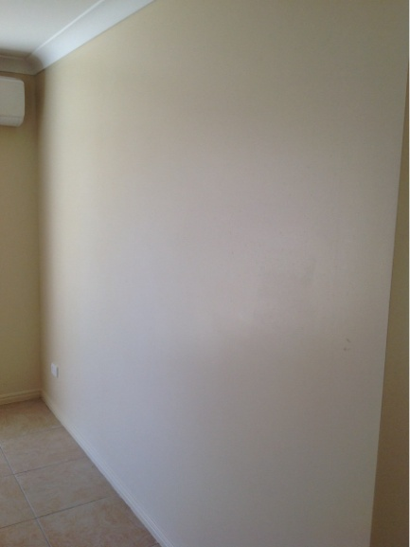  Lounge Room 1

