INSURED/APPLICANT NAME: Misha Wallace | APPLICATION / POLICY #: 263527253
ADDRESS INSPECTED: Suite 8, 18 Broadway, New Market
ACTUAL YEAR BUILT: 1990 | DATE INSPECTED: 03/20/2016

Minimum Photo Requirement
Front elevation Y Rear elevation
Main Electrical Service Panel with interior door label
HVAC heating systems equipment (with dated manufacturer's plate)
ALL hazards or deficiencies noted in this report
A Florida-licensed inspector MUST complete, sign and date this form

Electrical System (*SEPARATE DOCUMENTATION OF ANY ALUMINUM WIRING REMEDIATION MUST BE PROVIDED AND CERTIFIED BY A LICENSED ELECTRICIAN)
Main Panel:  Panel Age: 1990  Year Last Updated: 2000  Amps:  Less than 60A Fuse  60A Fuse  100A Fuse  100A CB  200A CB  Other (specify): Other | Panel #2 (if present):  Year Panel #2 added: 1995  Purpose of Panel 2: 2001  Amps:  Less than 60A Fuse  60A Fuse  100A Fuse  100A CB  200A CB  Other (specify): Nothing | Total System Amps: 100A  Wiring Type  Cooper Wiring, NM, BX, Conduit:  Active Knob & Tube or cloth wiring:  Aluminium Branch Wiring*:  Other (specify): Nothing
Hazards Present  Blowing Fuses or Breakers Over Fusing  Empty Breaker Sockets Double Taps  Lose Wiring Exposed/Unsafe Wiring  Improper Grounding Electrical Panel Brand/Model Some brand  Other (Explain) Nothing actually  Is the electrical system in good working order? Yes No (Explain) |  | *if single strand (aluminium branch) wiring, provide details of all remediation. Separate documentation of all work must be provided  Entire home rewired with copper  Connections repaired via COPALUM® crimp  Connections repaired via AlumiConn®
Use the Additional Comments/Observations section below to provide full details of any noted updates, hazards, etc.

Heating System
Age of System: 10  Are the heating, ventilation and air conditioning systems in good working order?  Yes No | Year Last Updated: 2003  Hazards Present  Wood Burning Stove or central gas fireplace not professionally installed? Yes No  Space heater used as primary heat source? Yes No | Central HVAC Yes No  If not central, indicate primary heat source and fuel type Gas  Is the source portable? Yes No
Use the Additional Comments/Observations section below to provide full details of any noted updates, hazards, etc.

Plumbing System
Age of System: 1009  Type of Pipes  Copper  PVC  Galvanized  Polybutylene  Other (specify): Others | Year Last Updated: 2000  Is the plumbing system in good working order?  Yes No | Deficiencies (check all that apply):  Active leak  Indication of prior lead(s)  Connections/Hoses leaking or cracked  Water Heater (explain)  Other (explain)
Use the Additional Comments/Observations section below to provide full details of any noted updates, hazards, etc.

Roof – With 2 Roof Photos, This Portion can take the place of the roof condition certification form (CIT RCF -1)
Predominant Roof  Covering Material Shingle  Roof Age (Years) 1990  Remaining Useful Life 50  Date of Last Roofing Permit 1928-7-7  Date of Last Update: 2000-8-8  If updated (check one)  Full Replacement  Partial Replacement  % of Replacement Per  Overall Condition of Roof  Excellent  Good  Fair  Poor (explain) | Secondary Roof  Covering Material  Roof Age (Years)  Remaining Useful Life  Date of Last Roofing Permit  Date of Last Update:  If updated (check one)  Full Replacement  Partial Replacement  % of Replacement  Overall Condition of Roof  Excellent  Good  Fair  Poor (explain) | Any visible signs of Damage/deterioration? (describe) (e.g. curling/ lifted/ loose/ missing shingles or tiles, sagging or uneven roof deck)  Predominant Roof  Yes No  Secondary Roof  Yes No  Any visible signs of leaks?  Predominant Roof  Yes No  Secondary Roof  Yes No
Use the Additional Comments/Observations section below to provide full details of any noted updates, hazards, etc. for all roof coverings.

Roof - Additional Comments or Observations (Use Additional Pages As Needed):
Predominant Roof - Cc1
Secondary Roof -
All 4-Point Inspections must be inspected and completed by a verifiable Florida-Licensed inspector. I certify that the above statements are true and correct.
 |  | Inspector |  | Your License ID No. |  | 03/20/2016
Inspector Signature |  | Title |  | License Number |  | Date

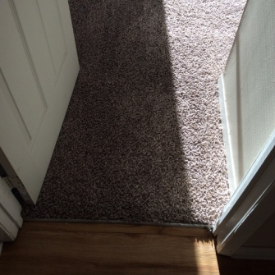  Minimum Photo Requirement - Front elevation | Minimum Photo Requirement - Front elevation | 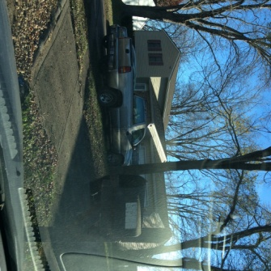  Minimum Photo Requirement - Rear elevation
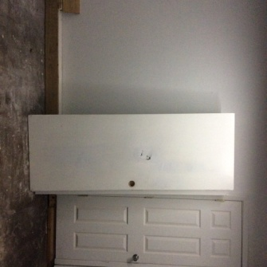  Minimum Photo Requirement - Rear elevation | 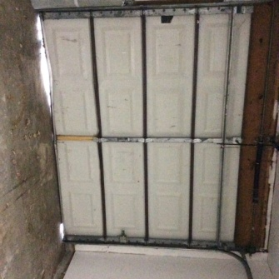  Minimum Photo Requirement - Main Electrical Service Panel with interior door label

A 4-Point Inspection is required for all homeowner, dwelling and mobile home applications for properties over 30 years old.
The citizens 4-Point Inspection form includes the minimum data needed for Underwriting to properly evaluate a property application. While this specific form is not required, any other inspection submitted for consideration must include at least this level of detail to be acceptable to Citizens.
Photo Requirements
Photos must accompany each 4-Point inspection submitted to Citizens. The minimum photo requirement for all submissions is a front and rear elevation. However, there are additional photo requirements for a 4-Point inspection such as:
- Open Main Electrical Panel and Interior Door  - ALL hazards or deficiencies noted | - HVAC heating system (with dated manufacturer’s plate)

Roof Requirements
The Citizens 4-Point inspection may be submitted in lieu of the Citizens Roof Condition Certification Form (CIT RCF-1) if a minimum of 2 photos of the roof are also provided. This will satisfy the required roof documentation listed in the Citizens Rules Manual.

Inspector Requirements
An inspection forms must be inspected and completed by a verifiable Florida-licensed professional. Without a verifiable, certified inspector’s dated signature, the form will not be accepted. The following FLORIDA-LICENSED individuals may complete a 4-Point Inspection for Citizens in its entirety:
Note: A trade-specific, licensed professional may sign off only on their trade component of the 4-Point inspection form (e.g., a roofing inspector may sign off only on the roof portion of the form)
- A general, residential, or building contractor  - A building code inspector  - A registered architect  - A home inspector | - A professional engineer  - A building code official who is authorized by the State of Florida to verify building code compliance

Certifying the Condition of Each System
The Florida-Licensed inspector is required to certify the condition of the electrical, HVAC and plumbing systems. “Acceptable Condition” means that each system is working as intended and there are no visible hazards of deficiencies.

Additional Comments or Observations
This section of the 4-Point inspection must be completed with full details/descriptions if any of the following are noted on the inspection.
Electrical System
Sample Comments here
Is the electrical system in good working order? Explain
Sample Explain about the situation.
Heating System
In a good operational standard
Plumbing System
High
Deficiencies – Explain
Leaking need repair.

Note to All Agents
The writing agent must fully review each 4-Point inspection submitted with an application for coverage in advance. It is the agent’s responsibility to ensure that all Citizens rules and requirements are met before the application is bound. Properties with electrical, heating or plumbing systems not in good working order or with existing hazards / deficiencies cannot be submitted to Citizens.

